PYTHON PROGRAMS

1. #!/usr/bin/python

a, b = 20, 10

c = a + b

print “\n Addition of two numbers is”, c

c = a – b

print “\n Subtraction of two numbers is”, c

c = a \* b

print “\n Multiplication of two numbers is”, c

c = a / b

print “\n Division of two numbers is”, c

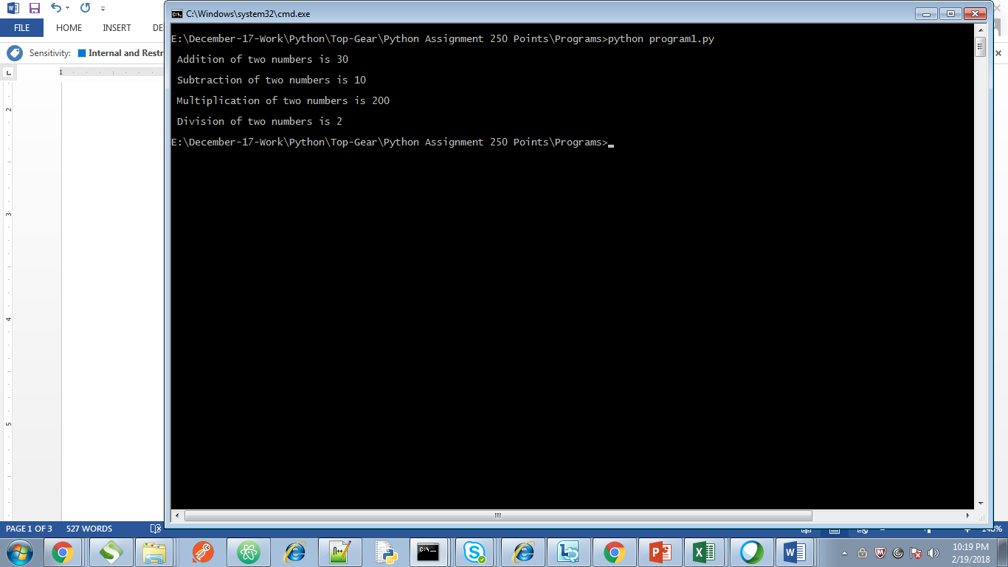

1. #!/usr/bin/python

a, b, c = 20, 10, 30

if a > b and a > c :

print “Biggest of three numbers is”, a

if b > a and b> c :

print “Biggest of three numbers is”, b

if c > a and c > b :

print “Biggest of three numbers is”, c

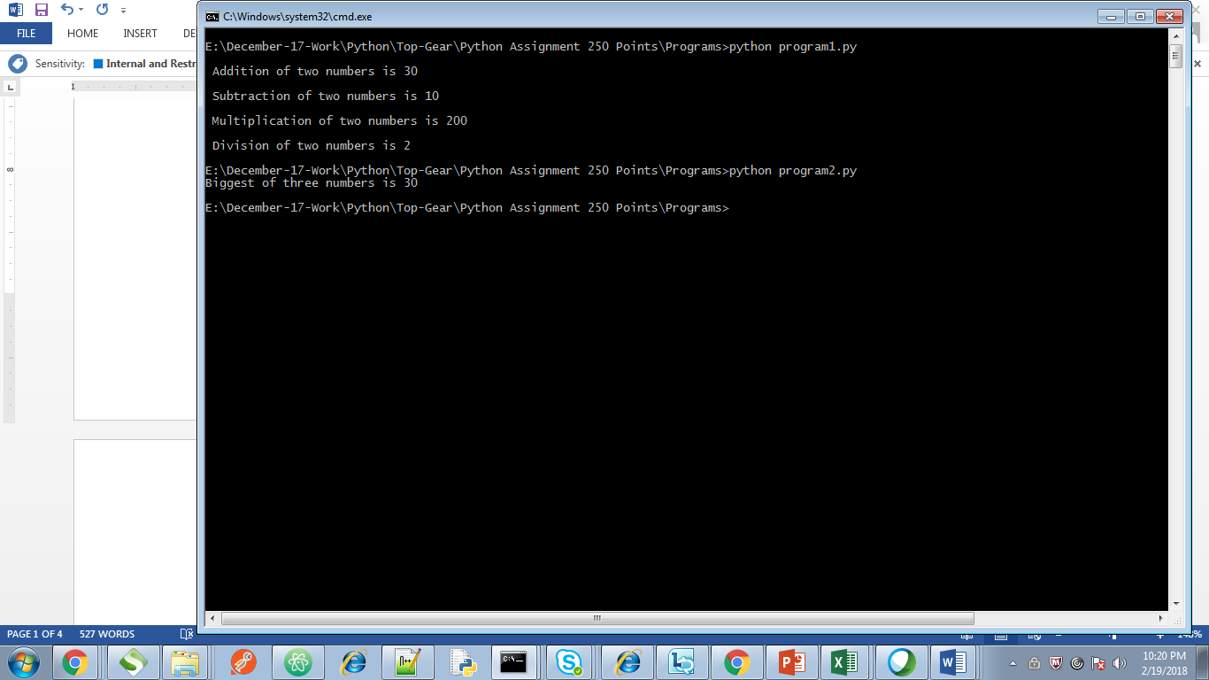

1. #!/usr/bin/python

a = 10

b = a % 2

if b == 0 :

print “ Given number is”, c, “even”

else :

print “Given number is”, c, “odd”

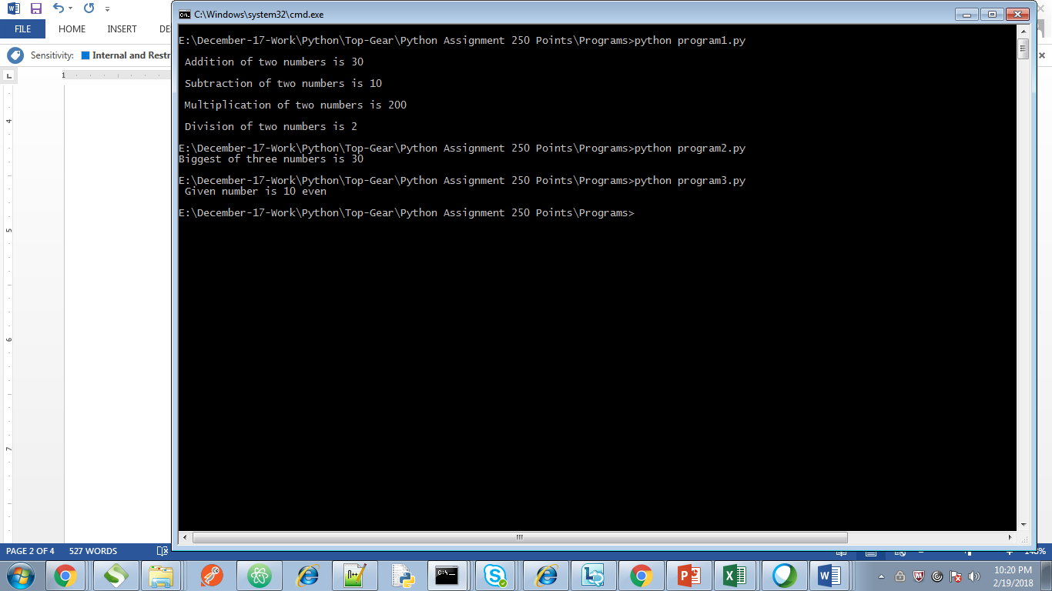

1. #!usr/bin/python

a = 7

for i in ( 2, a-1 )

if a % i == 0 :

print “ The given number “, a “ is not prime”

else :

print “ The given number “, a “is prime”

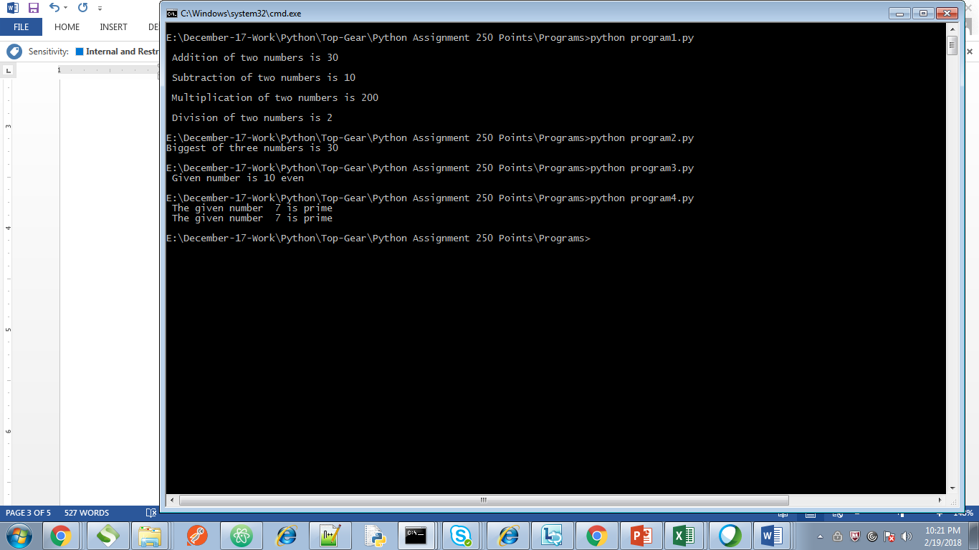

1. #!/usr/bin/python

import sys

print “ First number is ”, arg1

print “ Second number is ”, arg2

print “ Third number is ”, arg3

print “The biggest of three numbers is ”, max ( arg1, arg2, arg3 )

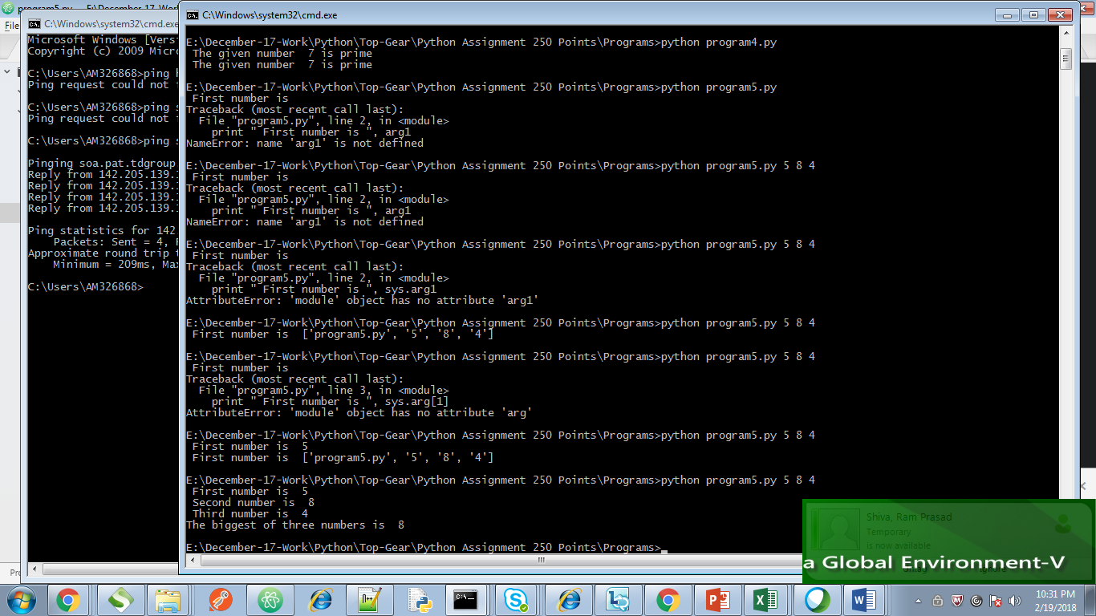

1. #!usr/bin/python

str1 = “Chennai”

str2 = “city”

for i in range str1

print “current letter is”, i

str3 = str1[2:5]

print “ sub-string is ”, str3

print “ Repeated string is “, str1 \* 100

print “ Concatenated string is “, str1 + str2

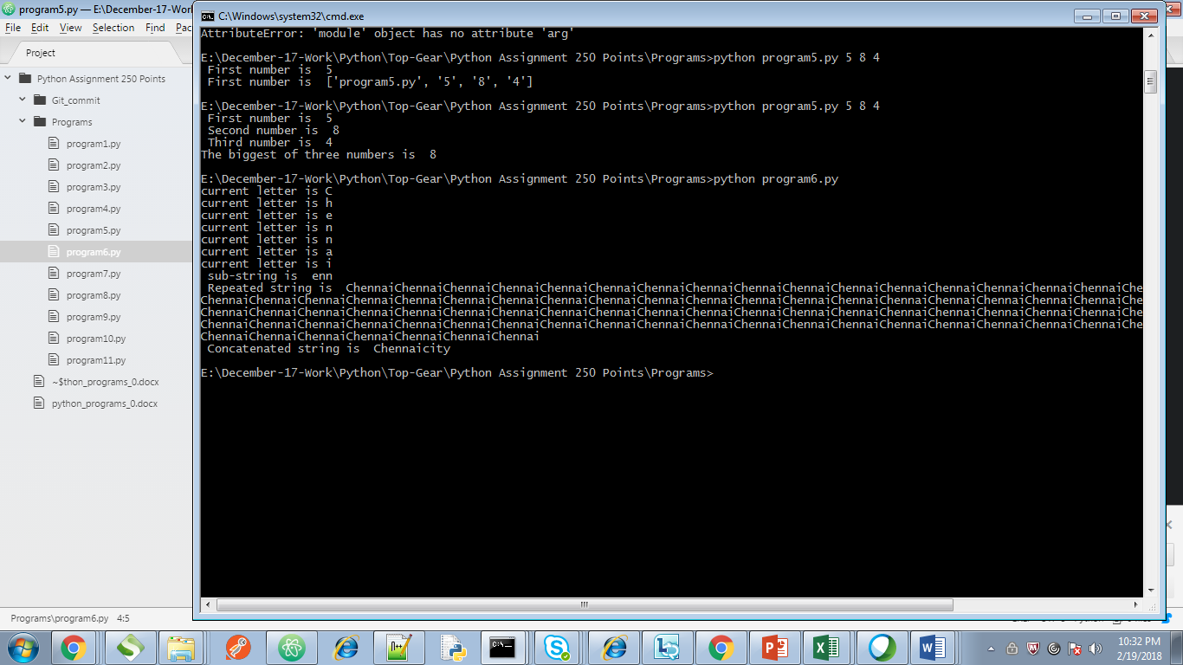

1. #!/usr/bin/python

List = [ 12, 23, ‘Hello’, 60.6, ‘Chennai’ ]

List1 = [ 21, 32, 60 ]

a = List [ 1:3 ]

b = List \* 2

c = List + List1

print List

print “\n”, a

print “\n”, b

print “\n”, c

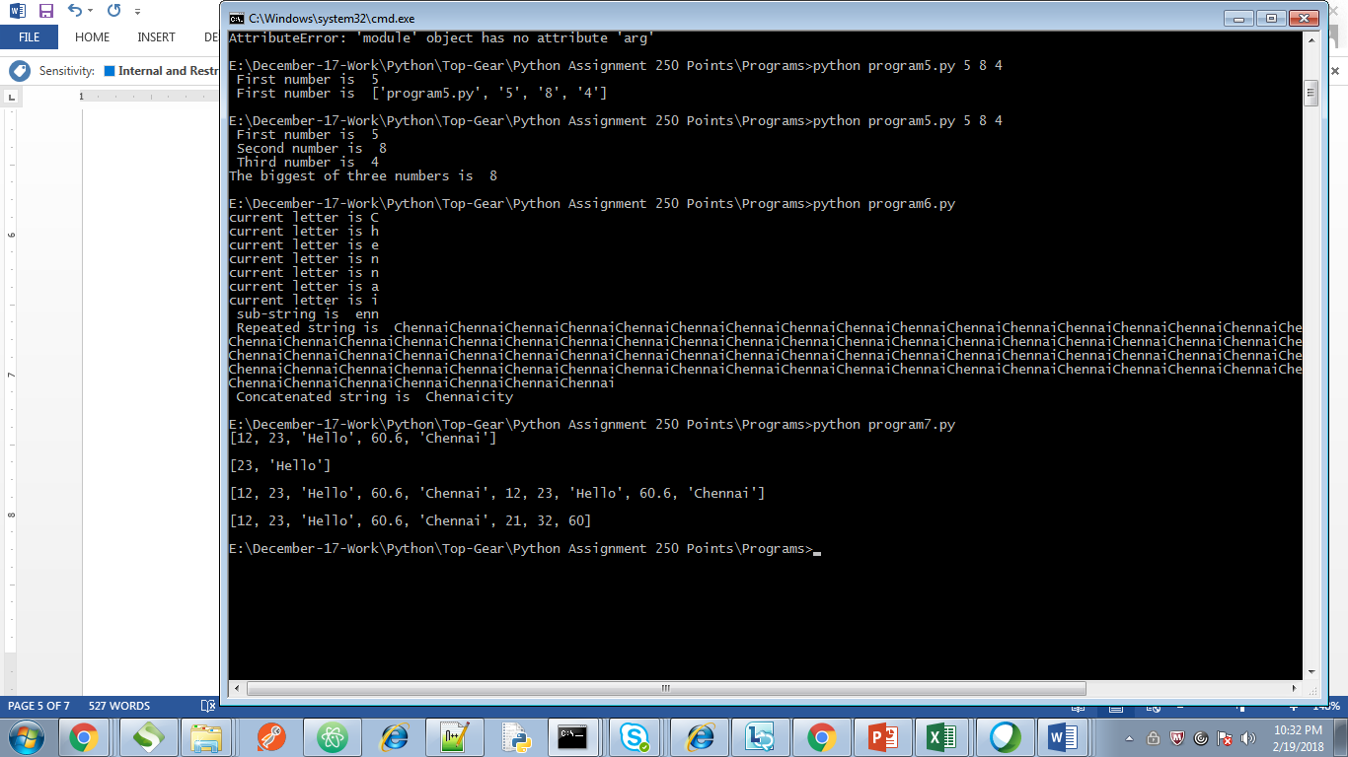

1. #!/usr/bin/python

Tuple = ( 12, 23, ‘Hello’, 60.6, ‘Chennai’ )

Tuple1 = ( 21, 32, 60 )

a = Tuple[ 1:3 ]

b = List \* 2

c = List + List1

print List

print “\n”, a

print “\n”, b

print “\n”, c

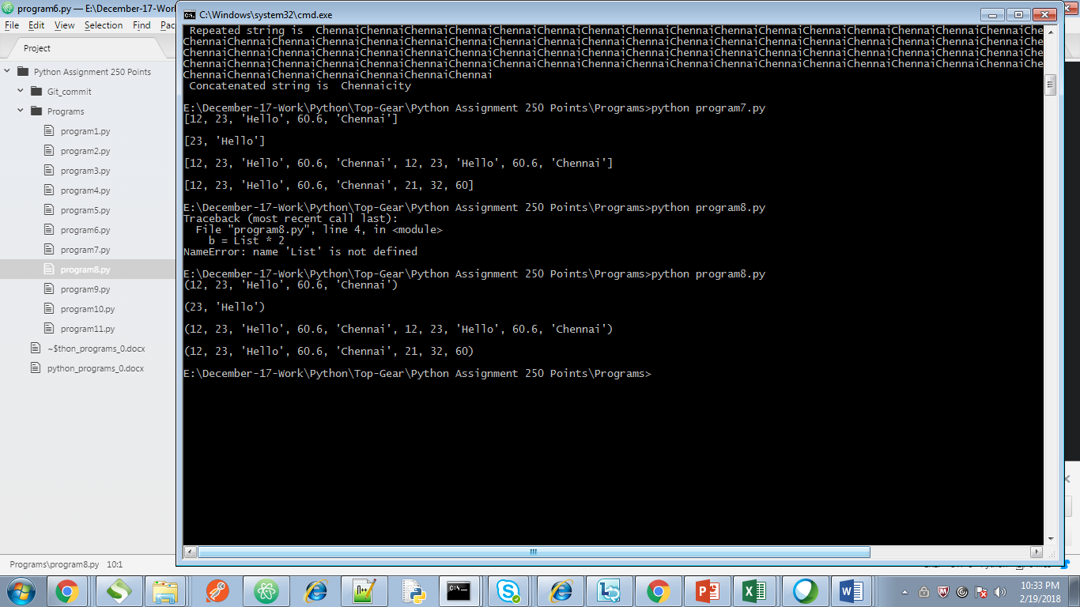

1. #!/usr/bin/python

a = complex(arg[0], arg[1])

b = complex (arg[2], arg[3])

c = a + b

print “\n Addition of two numbers is”, c

c = a – b

print “\n Subtraction of two numbers is”, c

c = a \* b

print “\n Multiplication of two numbers is”, c

c = a / b

print “\n Division of two numbers is”, c

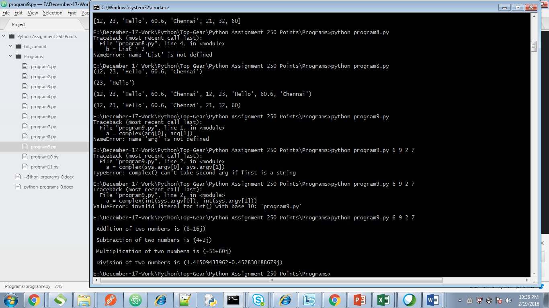

1. #!/usr/bin/python

arg[0] += arg[1]

print “\n Addition of two numbers is”, c

arg[0] -= arg[1]

print “\n Subtraction of two numbers is”, c

arg[0] \*= arg[1]

print “\n Multiplication of two numbers is”, c

arg[0] /= arg[1]

print “\n Division of two numbers is”, c

arg[0] %= arg[1]

print “\n modulus of two numbers is”, c

arg[0] \*\*= arg[1]

print “\n Exponentiation of two numbers is”, c

arg[0] //= arg[1]

print “\n Floor division of two numbers is”, c

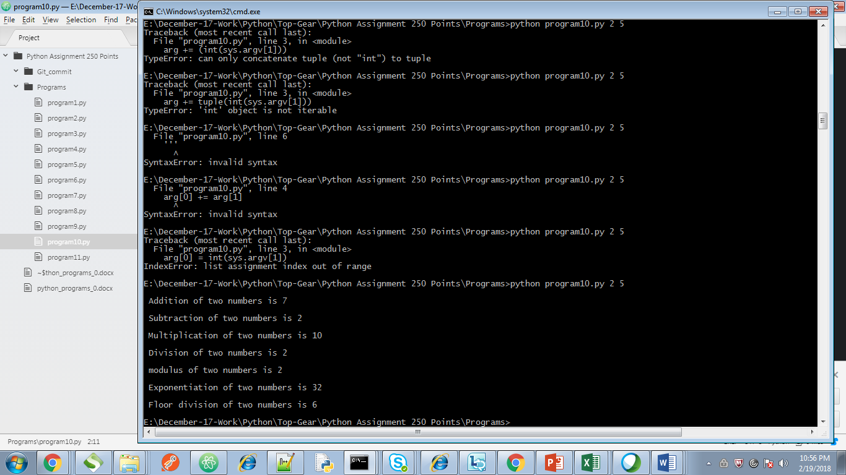ss

11) #!/usr/bin/python

a = arg[0] and arg[1]

b = arg[0] or arg[1]

c = not(arg[0] and arg[1])

print a

print b

print c

